Interactive Analysis Dashboard For Global Income Distribution
Project Documentation (Milestone 3)
Prepared By : Onkar Vyawahare
Project Domain : Data visualization
Project Overview
The outcome will be a user-friendly dashboard, embedded within web application, offering an intuitive interface for economists, researchers, policymakers, and the general public. This platform will help users explore global income inequality, understand disparities across different regions, and analyze trends in wealth distribution. The project will conclude with comprehensive testing to ensure dashboard accuracy and usability, supported by detailed documentation for future reference and enhancements.
Milestone Overview
Weeks 5-6: Web Application Development and Dashboard Integration
During this phase, a web application was developed to present the interactive analytics dashboard in a user-friendly environment. The Power BI dashboard was integrated into the website, enabling users to view, explore, and interact with global income distribution data through features such as filters, visualizations, and data insights. Additional components like user interface design, navigation pages, and data accessibility were implemented to enhance usability and provide a professional analytics platform.
Technology Stack
The project uses the following technologies for developing the web application, integrating the analytics dashboard, and managing data operations.
1. Backend Development
- Framework: Flask (Python 3.x) – Used to build the web application and handle server-side logic.
- Authentication & Security: Flask-Login – Manages user authentication, login sessions, and access control.
2. Database Management
- Database: SQLite – Lightweight database used for storing user data and application records.
- ORM: SQL Alchemy – Object Relational Mapper used to interact with the database using Python objects instead of SQL queries.
3. Frontend Development
- Core Technologies: HTML5, CSS3, JavaScript (ES6+) – Used to design and implement the user interface and interactive elements.
- UI Framework: Bootstrap 5 – Provides responsive layout and modern UI components.
- Icons: Bootstrap Icons – Used for visual icons across the website interface.
4. User Interface & Animations
- Animation Library: AOS (Animate On Scroll) – Adds smooth scrolling animations and improves user experience.
5. Data Processing & Analysis
- Libraries:
  - Pandas – Used for data manipulation and analysis.
  - NumPy – Used for numerical computations and data processing.
6. Reporting & Data Export
- Excel Reporting: OpenPyXL – Generates downloadable Excel reports from processed data.
7. Deployment
- Hosting Platform: PythonAnywhere – Used to deploy and host the web application online.
8. Database Management Tool
- Tool: Beekeeper Studio – Used for managing and browsing the SQLite database during development.

Software Platforms
The project uses the following platforms for data analysis, dashboard development, web application development, and deployment.
1. Data Visualization & Analytics
- Microsoft Power BI – Used for initial data modeling, dashboard creation, prototype visualization, and defining analytical KPIs for global income distribution analysis.
2. Data Management & Processing
- Microsoft Excel – Used for historical data storage, dataset cleaning, preprocessing, and preparing structured datasets for analysis.
3. Development Environment
- Visual Studio Code – Used as the primary Integrated Development Environment (IDE) for developing the web application, writing backend code, and managing project files.
4. Deployment Platform
- PythonAnywhere – Used for deploying and hosting the web application so users can access the analytics dashboard online.
5. Database Management Tool
- Beekeeper Studio – Used to manage, view, and edit the SQLite database during development.
Publishing the Power BI Dashboard
The completed dashboard from Milestone 2 was published to the Power BI Service in order to generate an embed link that allows integration with a web application.
Steps followed:
1. The Power BI report was opened in Power BI Desktop.
2. The report was published to Power BI Service using the Publish option.
3. The report was uploaded to the My Workspace environment.
4. The published dashboard was accessed through Power BI Service.
5. An embed link was generated using the option:
File → Embed Report → Website or Portal
This embed link allows the Power BI dashboard to be displayed inside a web application.
Web Application Development
A professional web application was developed to host the Power BI dashboard and provide additional contextual information for users. The application includes multiple pages designed to improve user experience and navigation.
Website Structure
The web application consists of the following pages:
1. Authentication System
The platform provides a secure authentication system with separate login interfaces for users and administrators. The User Login allows registered users to access the Global Income Distribution Analytics dashboard and explore interactive data visualizations. The Admin Login provides restricted access for system administrators to manage platform functionalities and maintain system control. The interface is designed with a modern responsive UI, ensuring secure authentication, easy navigation, and a professional user experience.
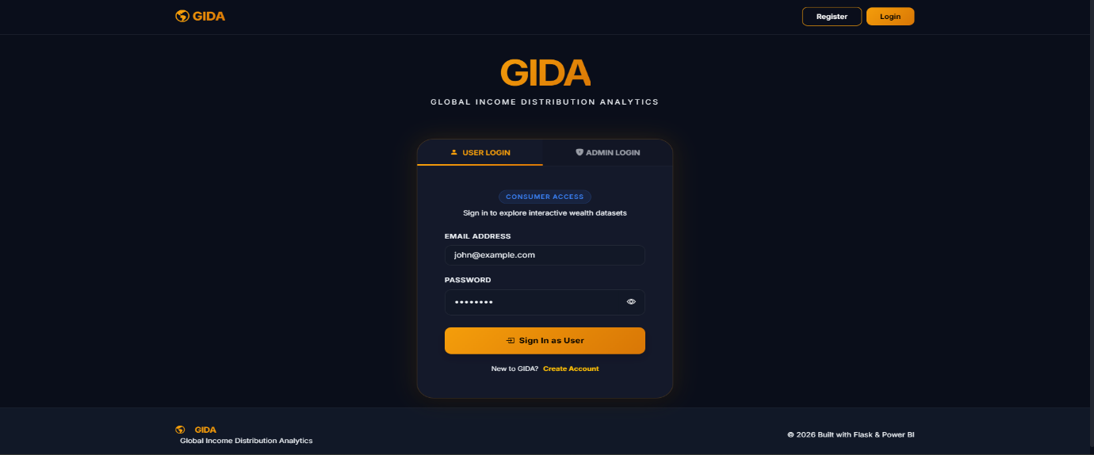
2. Home Page
The GIDA Home Page serves as a high-impact landing portal designed to introduce users to the platform's mission of decoding global economic disparities.
Key Sections:
- Hero Section
- Live Metrics (Project Overview)
- Inequality Framework
- Automated Insights
- Global Navigation
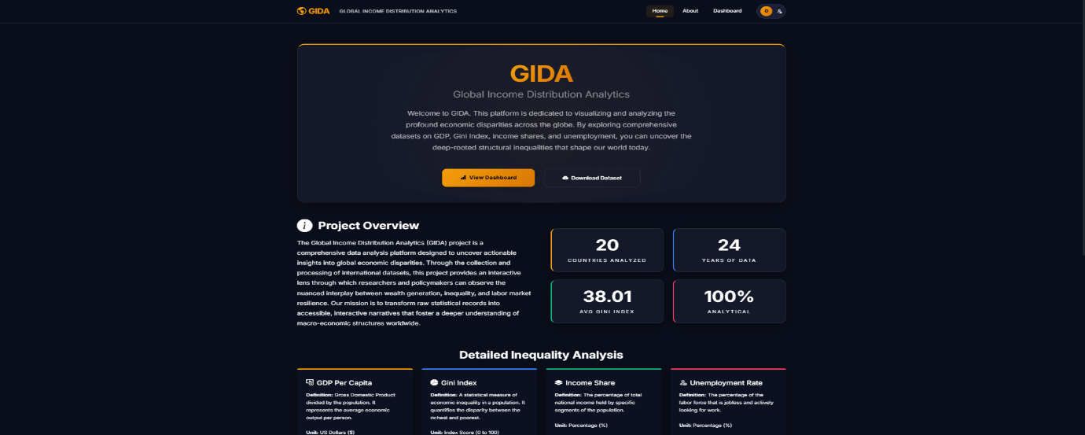
3. About Page
The About page is the strategic knowledge repository of the platform, detailing the mission, societal context, and structural factors driving global income disparity.
Key Sections:
- Strategic Objective
- Problem Statement
- The Inequality Matrix
- Structural Patterns
- Driving Factors
- The Ladder Analogy
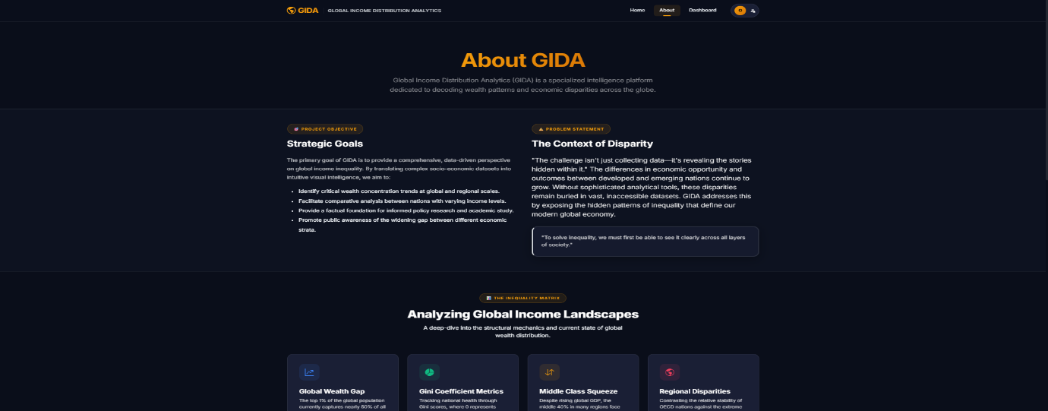
4. Dashboard Page
The GIDA Dashboard is the core analytical engine of the platform, providing high-performance visualizations and interactive tools to explore global economic data.
Key Features:
- Integrated Power BI Dashboard
- Country Comparative Analysis
- Interactive Action Hub
- Analytic Sections:
  - Global Overview
  - Regional Analysis
  - Trend Analysis
  - Correlation Studies
- Integrated Feedback Gateway
- Dynamic Controls
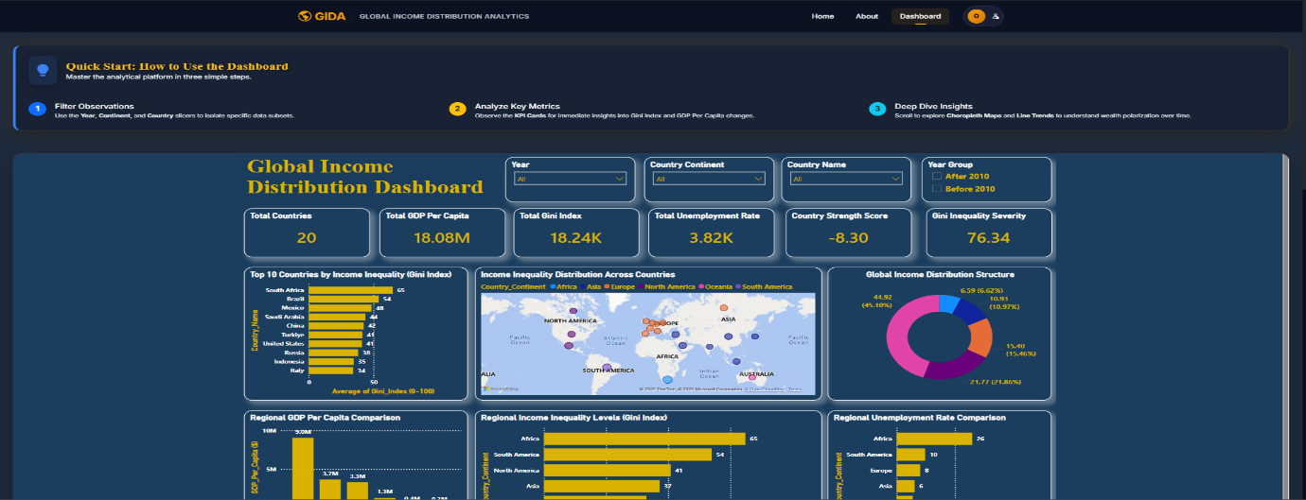
5. Admin Panel
The Admin Panel is the platform's command center, designed for monitoring system health, user growth, and community engagement.
Key Features:
- Real-Time Platform Analytics
- Growth Intelligence
  - Acquisition Velocity
  - Sentiment Pulse
  - Milestone Tracker
- User Management System
- Feedback & Insight Inbox
- Database Explorer (SQLite Viewer)
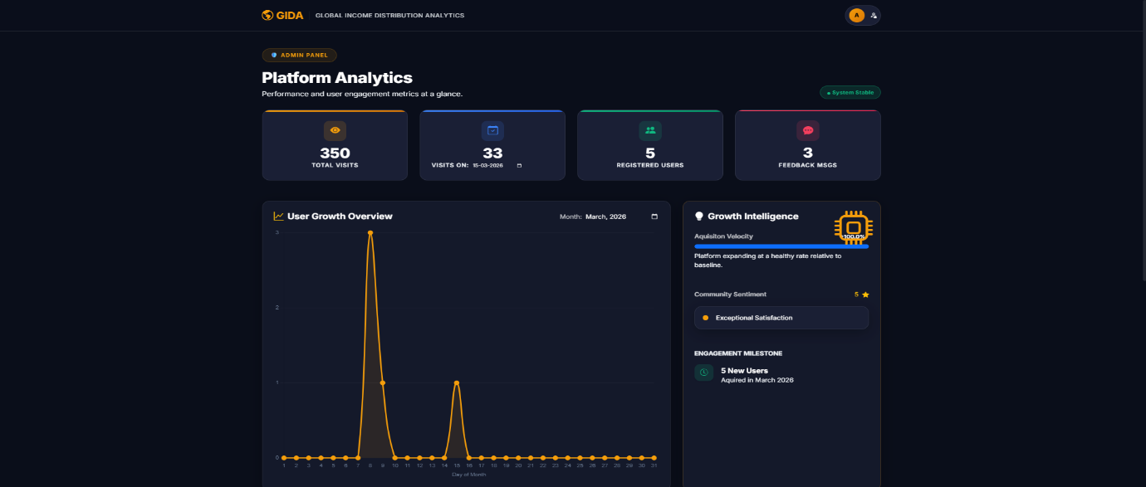
Features Of The Web Application
1. Interactive Analytics Dashboard
2. Integrated Intelligence Systems
3. Administrative Governance Center
4. Engagement & Documentation Hubs
5. Data Export & Reporting
6. Premium User Experience
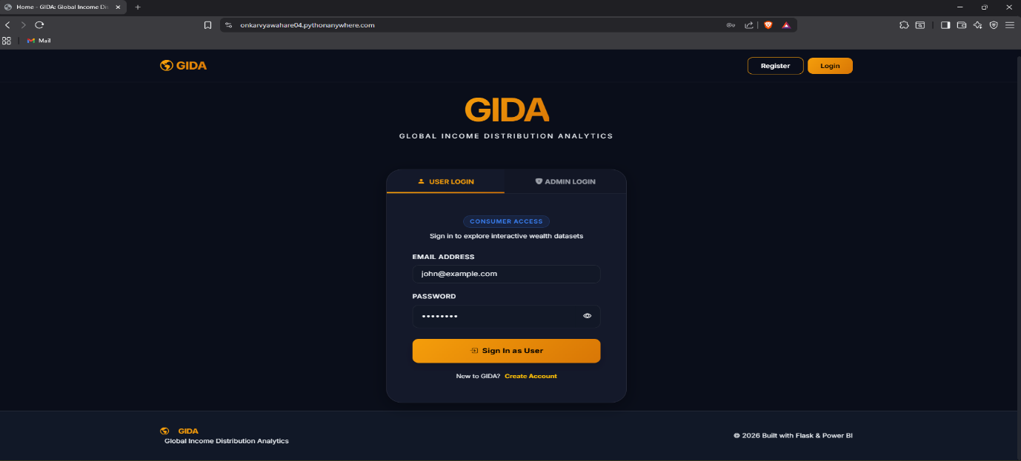
Live Demo Link
https://onkarvyawahare04.pythonanywhere.com/
- Admin Credentials : admin@gida.com
- Password : admin123
- GitHub Repository : https://github.com/Springboard-Internship-2025/Interactive-Analytics-Dashboard-for-Global-Income-Distribution_Feb_Batch-8_2026

Conclusion
GIDA (Global Income Distribution Analytics) successfully bridges the gap between complex socio-economic datasets and actionable human understanding. By integrating high-performance visualizations, interactive comparative tools, and institutional-grade reporting, the platform transforms raw economic indicators into a compelling narrative on global disparity.

